

Wesley

*MEMORIAL UMC*

*EVERYONE IN*

*MINISTRY*

*2025*

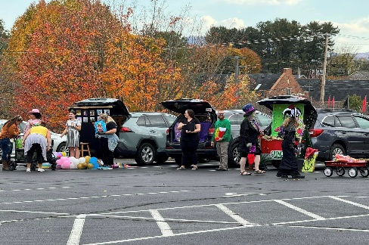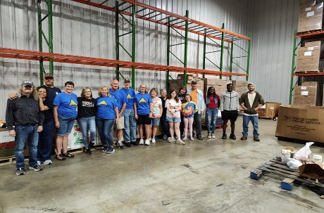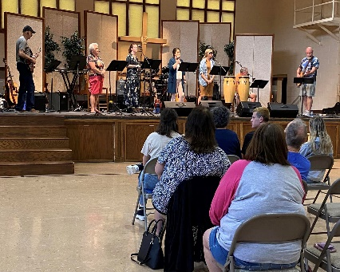

# Worship—Contemporary

 Serve as Greeter/Take Attendance

 Serve as Liturgist

 Run camera for Live Stream

 Assist with preparation of Communion Elements

 Assist with Serving Holy Communion

 Greeter at special services

 Assist with Holy Communion

Christmas Eve Service

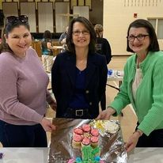 Audiovisual

 Run Camera for Live Stream

# Worship—Traditional

 Acolyte (Specifically for youth/children)

 Serve as Usher

 Serve as Greeter

 Serve as Liturgist

Write a Call to Worship

 Run camera for Live Stream

 Assist with preparation of Communion Elements

 Assist with Serving Holy Communion

 Assist with Altar Design

 Usher at special services

 Assist with Holy Communion at

Christmas Eve Services

 Audiovisual

**FULL NAME: _____________________________________________________________________________________________________________________**

**THROUGH GOD'S HELP, I WILL COMMIT TO DO GOD’S WORK THROUGH WESLEY MEMORIAL UNITED METHODIST CHURCH BY SERVING FOR:**

**[Please check appropriate boxes in ministry areas where you would like to serve.]**

# Nursery Ministry

 Work in Nursery as needed

 Provide snacks/supplies

# Children Ministry (age 5—5th grade)

 Upkeep “the Nest”

 Kids in Action  AV  Extra Hand

 Assist with Second Sunday classes

 Assist with special classes

 Help with Special Events

 Spring  Summer  Fall  Winter

 Contact if there is a need in

Children’s Ministry

**Adult Ministry**

 Teach Class

 Substitute Teach Adult Class

 Lead a Bible Study/Small Group

 Lead a Life Group

 Help with Men’s Ministry

**Family Life Ministry**

 Plan special events that include

Family Fellowship and Church

 Assist with Church Wide Picnic

 Assist Trunks of Treats

 Assist with Tree Lighting

# Missions

 Assist with Family Promise

 Deliver monthly food items

 Deliver emphasis items

 Provide food for Good Samaritan

 Serve on Mission Team (i.e. Habitat/ASP)

 Assist with food distribution

at East Pine Grove Park UMC

 Serve on Disaster Work Team

 Be host for work teams

# Hospitality

 Host Welcome Table

 Hospitality Team

 Follow-up calls, notes & emails

Serve as Sanctuary Shepherd

# Music

 Vocal  9:00  10:15

 Instrument  9:00  10:15

 Handbells (on occasion)

#  Assist with music library

# Congregational Care Ministry

 Prayer ministry network

 Grief Care Provide food  
 Transportation for  Sunday  Weekday  
 Meals for sick/hospitalized

# Building & Grounds Ministry

 Water plants  Indoors  Outdoors

 Minor building repairs

 Plumbing  Electrical

 Playground equipment repairs/maintenance

 Exterior Maintenance

(painting/windows, etc.)

 Custodial needs

 Set up/take down for church activities

# Office Ministry

 Office volunteer

 Fold  Newsletters  Bulletins

# Outreach

 Lead Devotional at Princeton Transitional

 Provide food for Neighbor to Neighbor

____Tuesday ___Thursday   
 Greeter for Neighbor to Neighbor

____Tuesday ___Thursday

 Be a Friend to New Life Medicine

Staff Person

 Help with special events,

 Package and Deliver cookies/brownies for Christmas Outreach to Retailers (December) and Grab-and-Go Goodies for First Responders (February)

 Help with Dinner Church

___ food __ set up

___ greeter/host ___ clean-up